Title of the Experiment: Analysis of RLC Parallel Circuit and Verification of KCL in AC Circuits.

Objective:
- To study the behavior and characteristics of a parallel RLC circuit.
- To verify Kirchhoff’s Current Law (KCL) for AC circuits by comparing measured and calculated current values.

Introduction (Basic Theory):
In an AC parallel circuit, the voltage across all branches is identical, while the total current is the phasor sum of the individual branch currents. Unlike DC circuits, AC currents cannot be added algebraically because of the phase difference between the resistor, inductor, and capacitor.
The total admittance ($Y$) of the circuit is the reciprocal of the total impedance ($Z$). For a parallel RLC circuit, the relationship between the branch currents is given by:

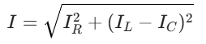
Where:
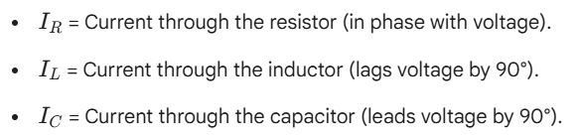

Proper Calculation:

When f = 1kHz
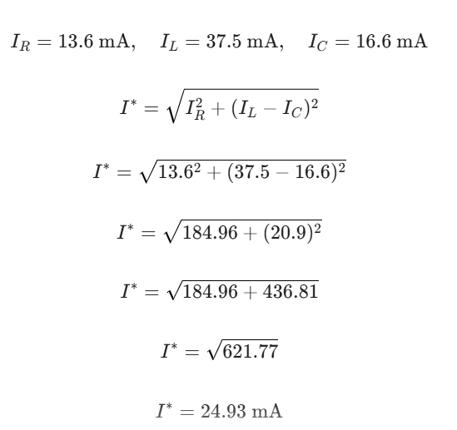
When f = 2 kHz
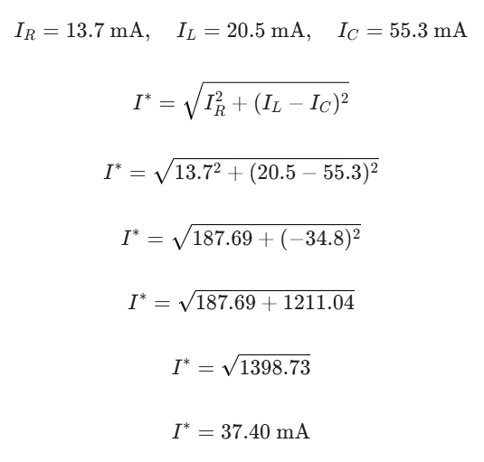
When f = 4 kHz
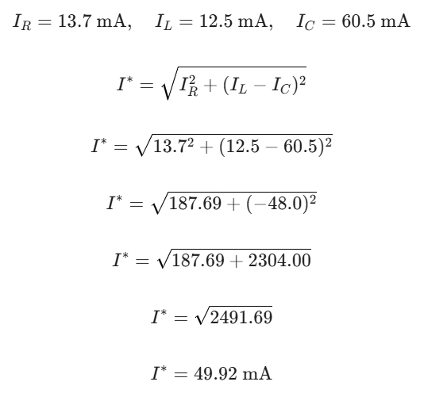
Equipment:
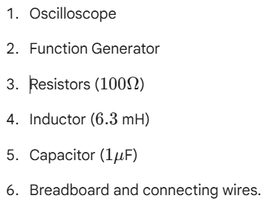

Procedure:
- The circuit was constructed on a breadboard as per the diagram provided in the manual.
- The function generator was used to set the input signal frequency at 1 kHz, 2 kHz, and 4 kHz.
- The oscilloscope was used to measure the current across different branches by observing the voltage drops.
- Measurements were recorded in the data table for each frequency setting.

Data Table:

Frequency (f) | 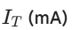 |  | 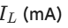 | 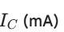
1 kHz | 35.7 | 13.6 | 37.5 | 16.6 | 24.93
2 kHz | 32.0 | 13.7 | 20.5 | 55.3 | 37.40
4 kHz | 42.8 | 13.7 | 12.5 | 60.5 | 49.92

Error Calculation:
The formula used is:
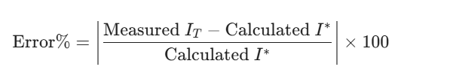
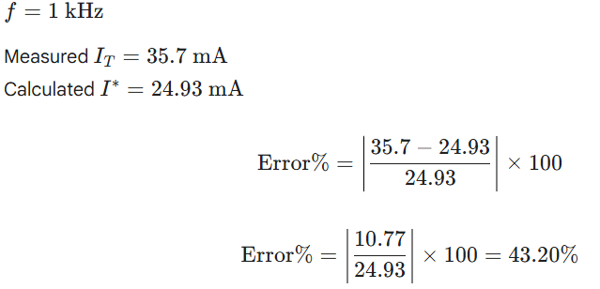

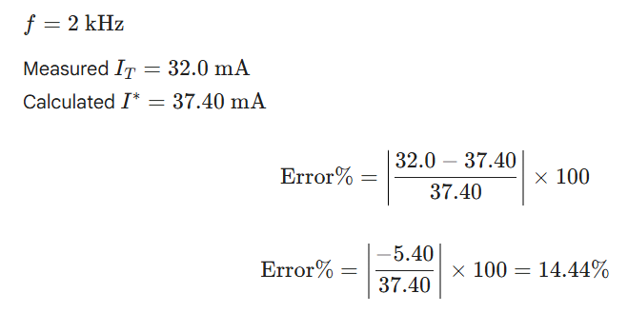

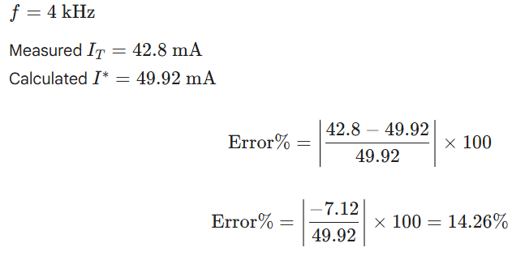

Result Analysis:

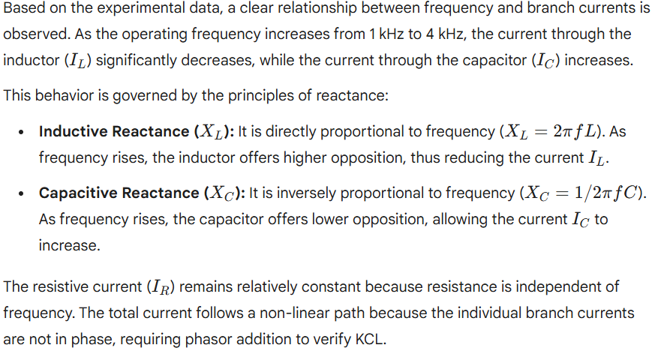

Conclusion:
